Experiment 6

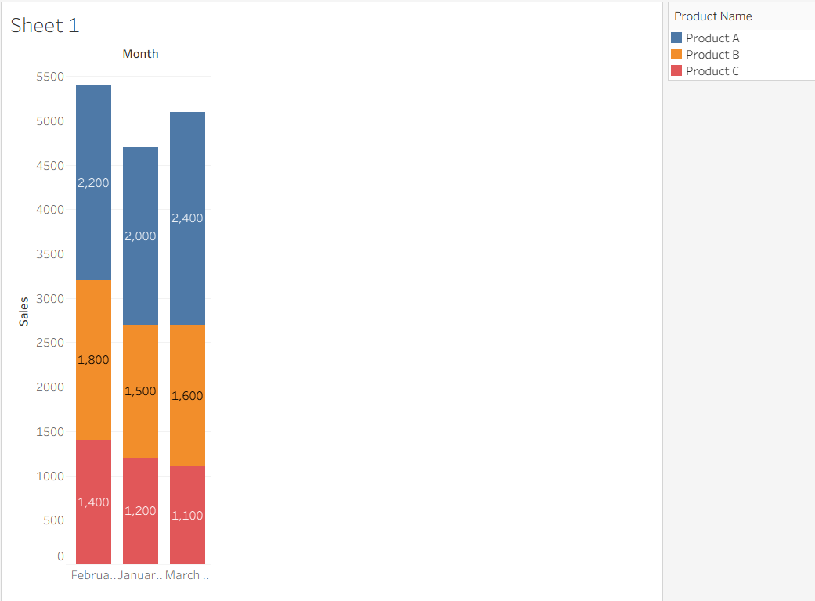
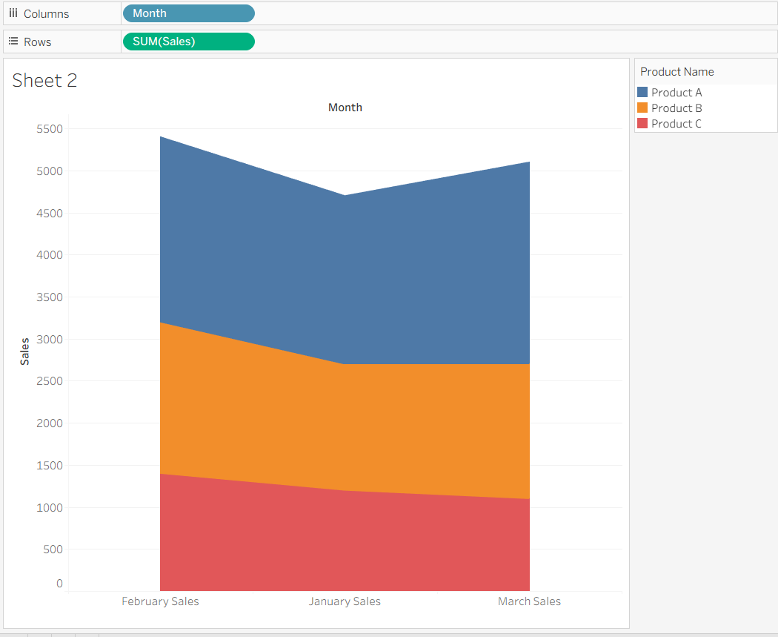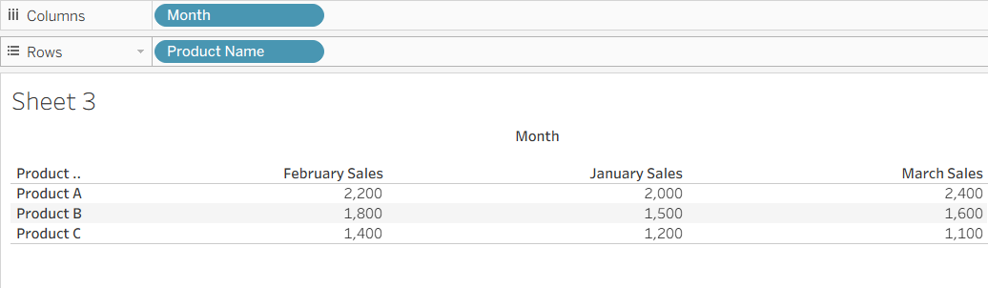
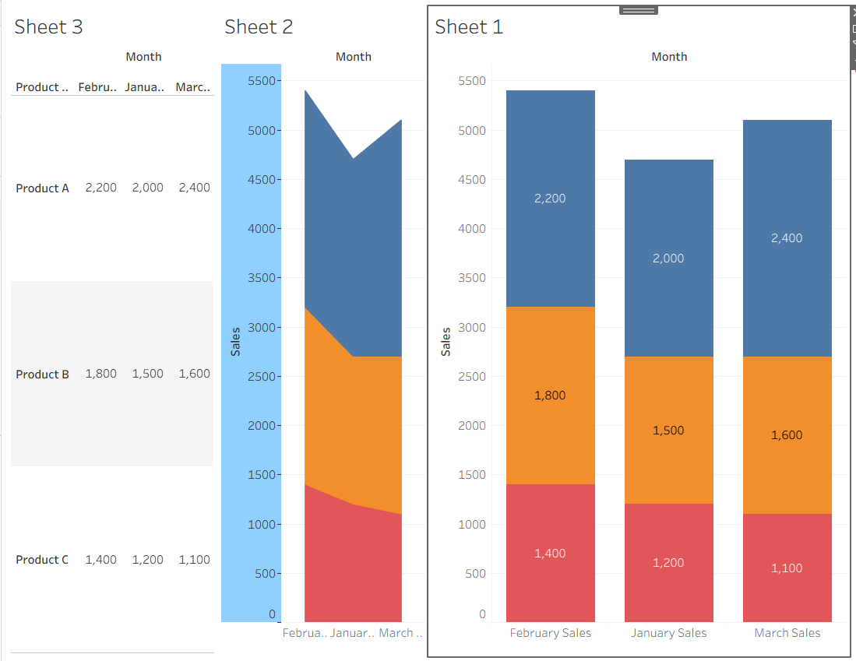

Procedure

1. Open Tableau and connect to the Product Sales dataset.
2. Import product-wise monthly sales data.
3. Create a grouped bar chart to compare sales of products for the first quarter.
4. Generate a stacked area chart to visualize overall sales trends.
5. Build a table displaying monthly sales of each product.
6. Add labels, legends, titles, and formatting to all visualizations.
7. Create a dashboard and place the grouped bar chart, stacked area chart, and table.
8. Add filters and interactive actions for data exploration.

